Name: Mriganka Patra

Email: [mriganka.patra@cognizant.com](mailto:mriganka.patra@cognizant.com)

Emp ID: 2415820

Day 18

Sprint 1 Submission

Task 1.2: As a System, I want to update fields based on predefined conditions to ensure data consistency.

1. Go to setup page > Object Manager
2. 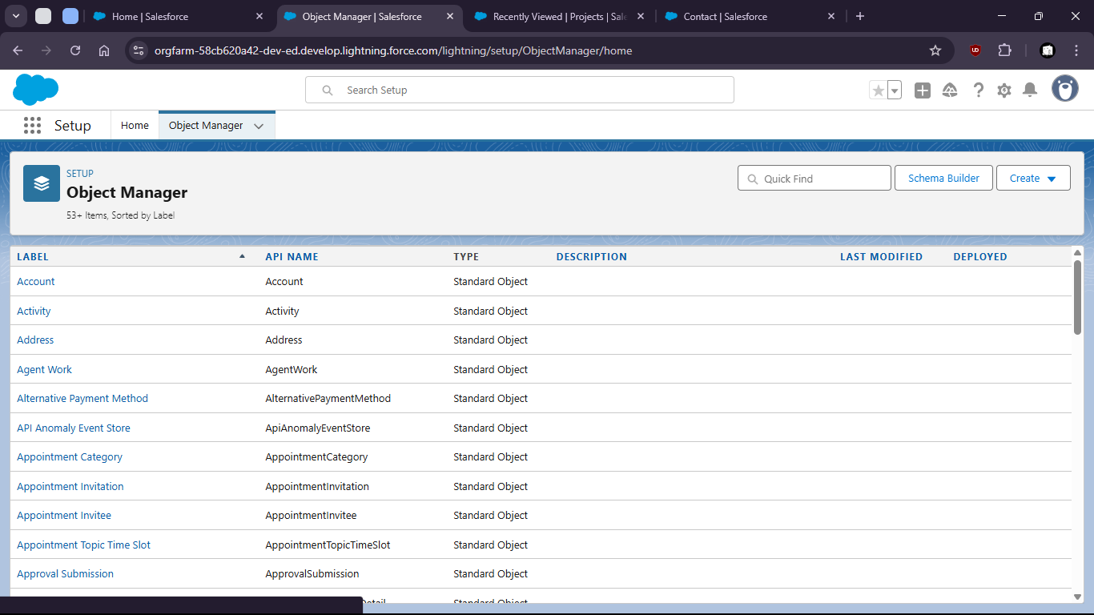
4. Select Project Object
6. 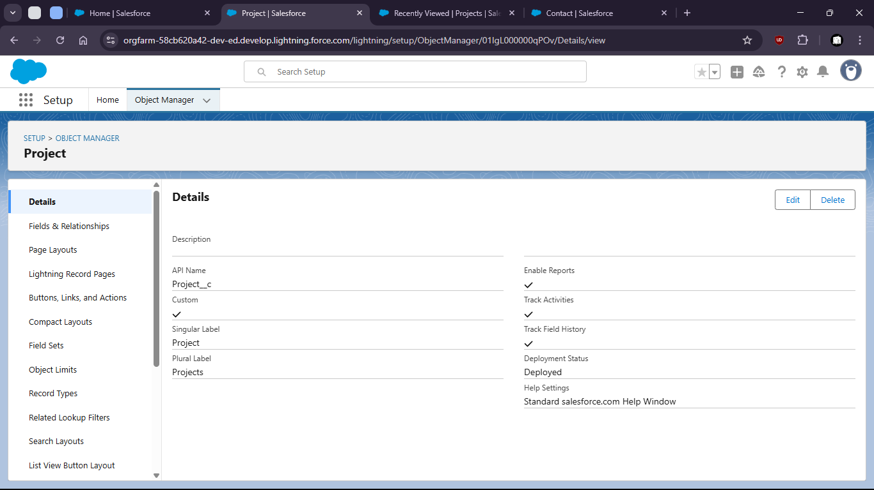
8. Go to validations rules
10. 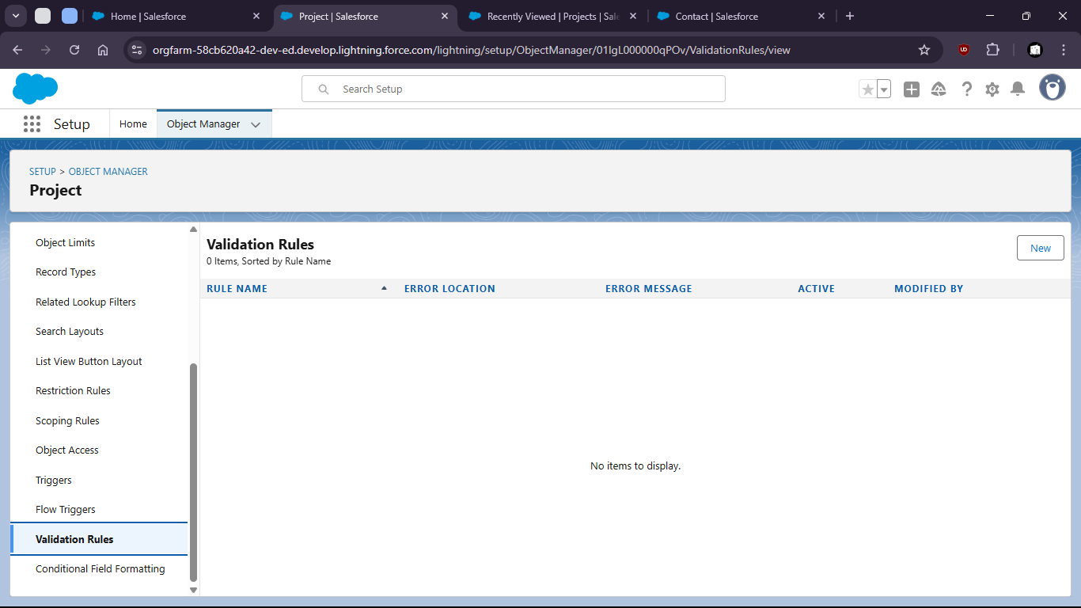
11. Without Validations Start Date can be later than End Date
13. 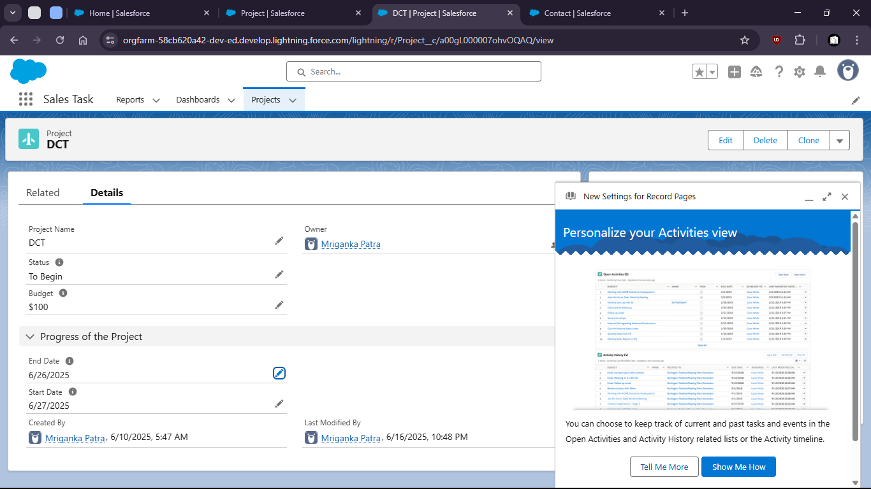
15. Create new Validation Rule:
17. 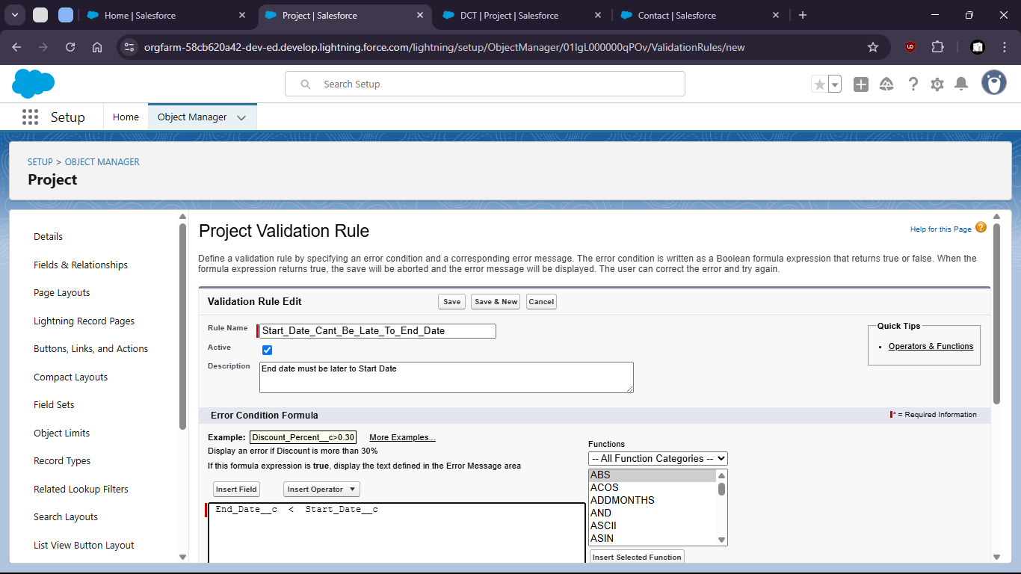
19. 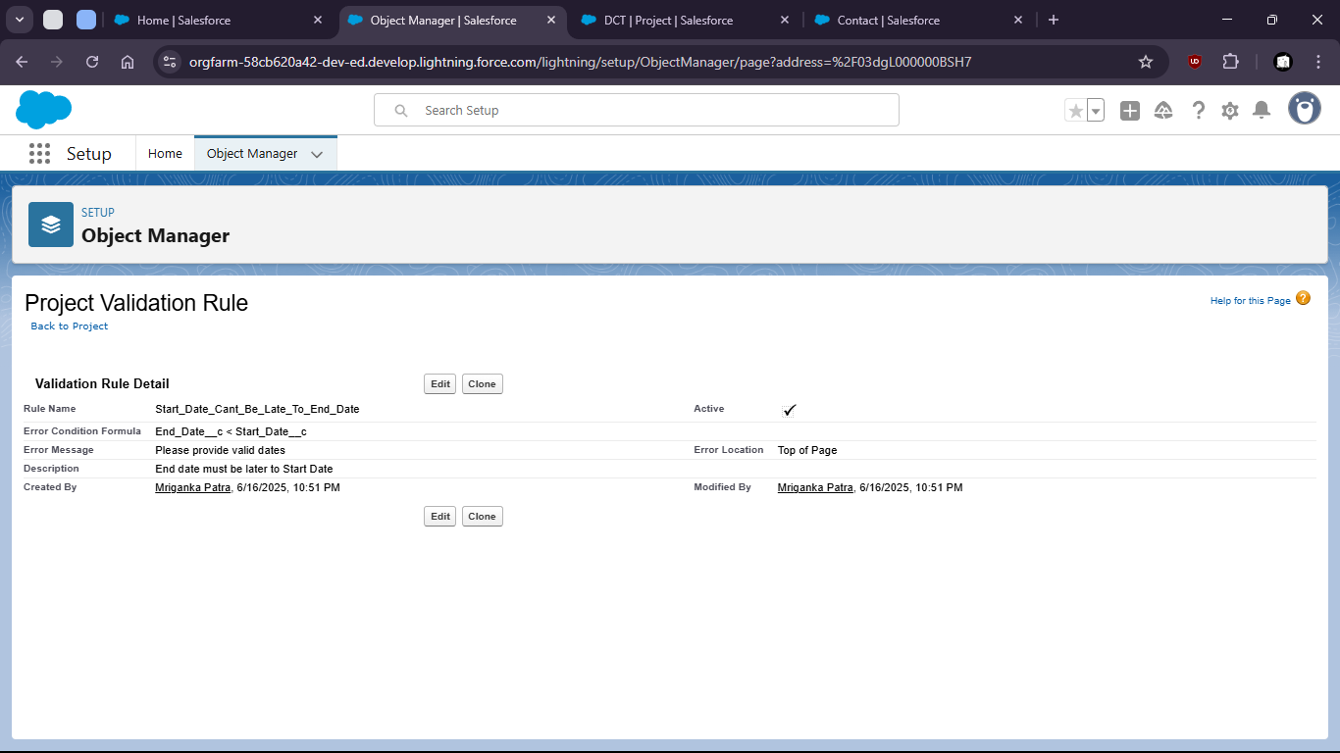
21. 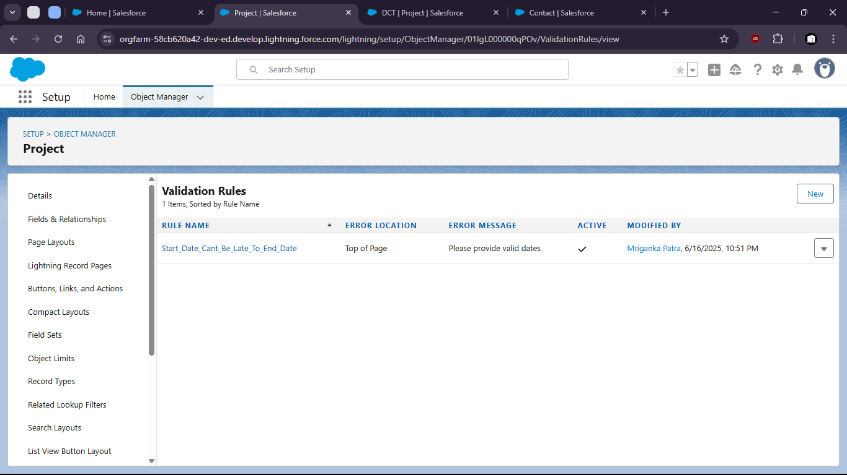
23. Now if we provide start date later than end date it shows error
25. 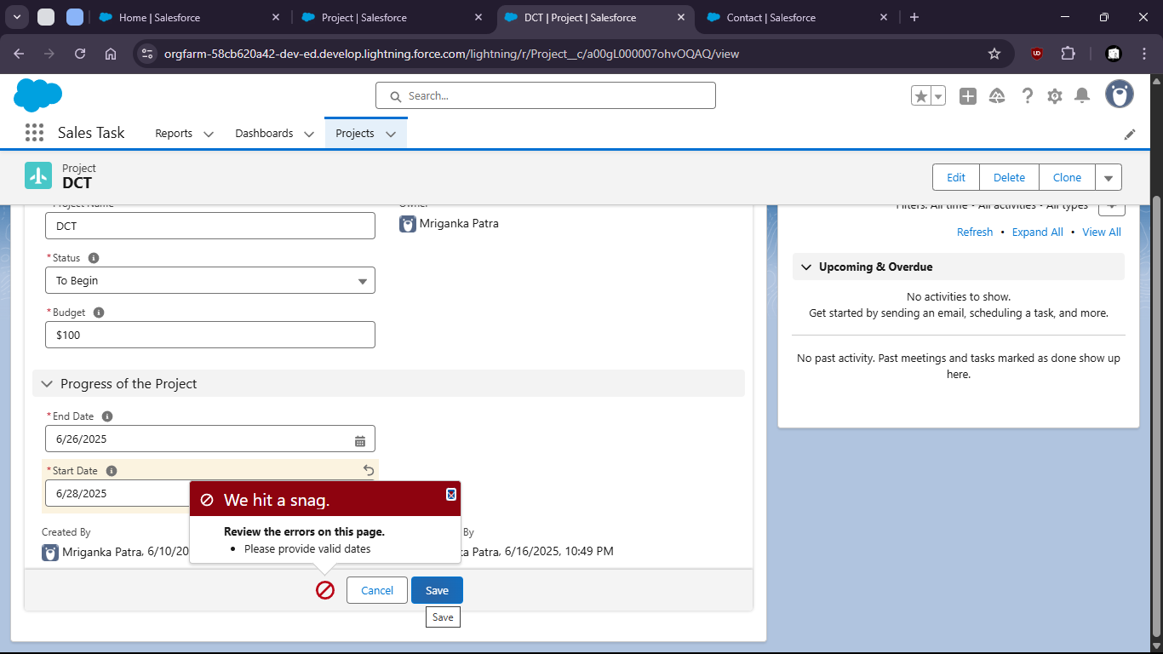
26. This way we can maintain data consistancy